General LAMMPS downloads are here: <http://lammps.sandia.gov/download.html>

**WINDOWS**:

1. Download and run the LAMMPS-64bit-latest.exe file. This can be obtained starting with <http://lammps.sandia.gov/download.html> or directly try <http://rpm.lammps.org/windows/64bit/> .
   1. This will generate executable files that run the software, install library dependencies, and generate a set of standard potentials
   2. The default install directory is C:\Program Files\LAMMPS 64-bit 23Oct2017
   3. Executable files can be found in the bin/ directory and we will specifically be using the lmp_serial.exe version
2. Double click the lmp_serial.exe file in the bin directory. You should have a window pop up that looks something like this

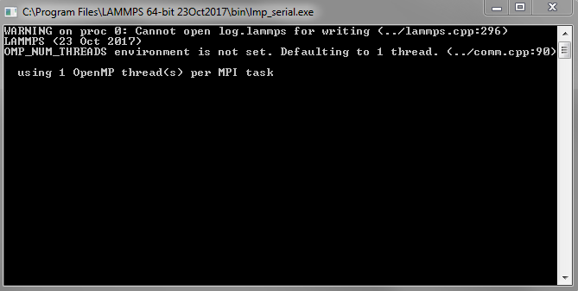

If you see this it means LAMMPS is installed correctly.

**MAC:**

1. Install homebrew, a package manager for OSX using the following command inside a terminal:

/usr/bin/ruby -e "$(curl -fsSL https://raw.githubusercontent.com/Homebrew/install/master/install)"

* 1. This command should be entered into the OSX terminal which can be opened from the utilities folder in applications

1. With homebrew installed use the following commands to install LAMMPS:

*brew install lammps*

1. Note that this may take a number of minutes depending on the speed of your laptop.
2. To test the install we can use the built in brew test package

brew test lammps -v

1. If the test succeeds then LAMMPS is installed correctly

**LINUX:** Distributions like Ubuntu, CentOS, etc. This assumes you have installed the GNU Compiler Collection and use the bash shell.

1. Make a directory in your home directory by pasting the following in a terminal:
   1. mkdir ~/lammps
2. Move lammps-stable.tar.gz into ~/lammps:
   1. mv <path to tarball> ~/lammps
3. Move into the installation directory:
   1. cd ~/lammps
4. Extract the contents:
   1. tar xf lammps-stable.tar.gz
5. Move into extracted directory:
   1. cd ~/lammps/lammps-29Oct20/src
6. Include a specific LAMMPS package (needed for the potential we will use):
   1. make yes-MANYBODY
7. Now to build from source:
   1. We can compile serial and parallel versions of LAMMPS:
      1. make serial
      2. make mpi (optional)
      3. make
   2. To speed up compilation, we can use multiple cores on a computer. Replace N with the integer number of cores you wish to use:
      1. make -j N serial
      2. make -j N mpi (optional)
      3. make
8. Now setup your environment variables by running the following:
   1. echo "export PATH=~/lammps/lammps-29Oct20/src:\$PATH" >> ~/.bashrc
   2. source ~/.bashrc
9. Check that both binary programs have been installed and should now be accessible in any directory (can exit the presented menu with ctrl+c):
   1. lmp_serial -h
   2. lmp_mpi -h
10. Additional packages can be installed by following the instructions on:
    1. https://lammps.sandia.gov/doc/Build_package.html

**Running a script file:**

The EquilRun.txt is a LAMMPS script file that sets up an MD run, executes the run, and performs some post-processing. In the lab we’ll be running files like this.

1. Download the EquilRun.txt file and the Al_mm.eam.fs potential file to a location in which you want to run. Make sure this is a directory you have write permission for or else you’ll get a bunch of errors about not being able to create file (specifically, do not use a directory in your Program Files directory on Windows as this usually does not have write permission and you will get an error). For this example I will assume the directory downloads/test_run/ . If you don’t have this directly you must create it (you can just create a folder with name test_run anywhere you want).
2. Open a terminal in windows (not a powershell but a command prompt) or mac in the test_run/ directory.
   1. Windows:
      1. In windows Shift+RightClick inside the test_run/ directory and select “Open command window here”. You can also open the command window anywhere and type >dir to see directory contents and type >cd XXX to change directories to XXX.
      2. Open the file explorer to test_run directory. Click on the address bar and type “cmd”.
   2. In OSX you can do the same but will need to enable the functionality first through   
      System Preferences > Keyboard > Shortcuts > Services  
      Enable **New Terminal at Folder**
3. Copy the lmp_serial.exe and zlib1.dll (if it exists) files from the LAMMPS install directory to the current directory
   1. Directory is: C:\Program Files\LAMMPS 64-bit 23Oct2017\bin by default on windows, /usr/local/opt/lammps/bin by default on mac
   2. Copying the executable is not technically required, but will make future commands shorter by not having to reference the full pathname later.
   3. Copying the zlib1.dll is not needed in some cases but fixed problems for some people.
4. Now we should have up to four files in the test_run/ directory
   1. lmp_serial.exe, EquilRun.txt, Al_mm.eam.fs, and zlib1.dll (if it existed on step 3)
5. Run the LAMMPS script using the following command:  
     
   lmp_serial.exe < EquilRun.txt
6. If the run is successful you will see a number of files generated in the test_run/ directory. In your terminal the last line should read  
    Total wall time: 0:00:01

Or some small number of seconds like this.

1. Congrats! You’ve run your first MD simulation!

**Running a script file on linux:**

1. Make a directory that will hold your job:
   1. mkdir ~/sample_run
   2. cd ~/sample_run
2. Move the EquilRun.txt and Al_mm.eam.fs files inside ~/sample_run:
   1. In terminal
      1. mv <path to EquilRun.txt> .
      2. mv <path to Al_mm_eam.fs> .
   2. In file manager (like Nemo, Nautilus, or similar) just click and drag sample files to created directory.
3. Run molecular dynamics with the following:
   1. lmp_serial < EquilRun.txt
   2. mpiexec -n N lmp_mpi < EquilRun.txt (optional and replace N with number of cores)
4. Check the file contents of log.lammps to ensure successful run.